**MBA 562 Intro Business Analytics**

**M4 Group Assignment**

**Group H075**

|  |  |
| --- | --- |
| **Team Member Name** | **Brief description of the team member’s contribution to this assignment** |
| Ansab Chapsi | Participated in group discussions to compare and finalize the data visuals and worked on part 5 of the McCandless Method of Data Visualization. |
| Daniel O’Malley | Participated in group discussions to compare and finalize the data visuals and worked on part 1 of the McCandless Method of Data Visualization. |
| Matt Strohschein | Participated in group discussions to compare and finalize the data visuals and worked on part 2 of the McCandless Method of Data Visualization. |
| Samuel Brandl | Participated in group discussions to compare and finalize the data visuals and worked on part 4 of the McCandless Method of Data Visualization. |
| Ryne Burgess | Participated in group discussions to compare and finalize the data visuals and worked on creating the data visual using Divvy ride data. |
| Will Kelley | Participated in group discussions to compare and finalize the data visuals and worked on part 3 of the McCandless Method of Data Visualization. |

Source: https://www.divvybikes.com/system-data

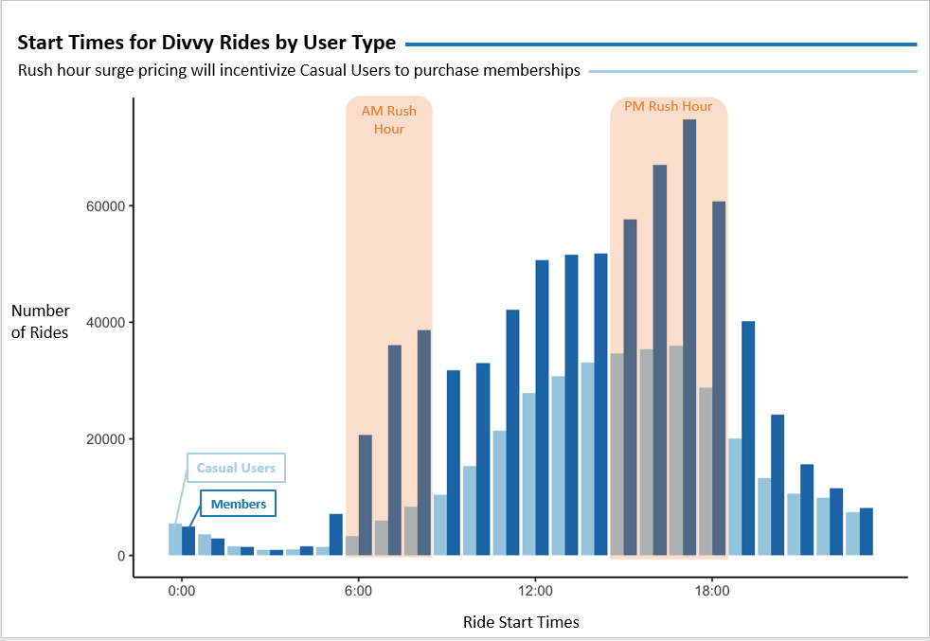

This is the ‘Start Times for Divvy Rides by User Type’ visual. The number of Divvy rides started per hour varies significantly throughout the day. This visual shows the quantity of and relationship between rides by casual users and members. The graphic gives a clear visual representation on how the usage by rider type changes throughout the day, including during rush hours. It also shows the relative ratio of rides by casual users to members each hour. The data, even if presented in summary format, would not show such a clear and easy to understand relationship between the variables.

Our data set is focused on ride start times over a six-month period beginning in November 2020 and ending in April 2021. The horizontal axis gives the time of day that each ride started. Zero represents midnight and the rest of the axis gives hours in military time. The vertical axis shows a count of the rides started. The dark blue columns represent Divvy member rides, and the light blue columns represent casual user rides. The light orange shaded area highlights the typical morning and afternoon rush hours in Chicago.

The insight gained from the bar chart of the past six months usage is that there is a significant increase in the number of rides Divvy members take during the AM and PM rush hours. Additionally, casual riders’ usage peaks during the PM Rush Hours as well.

As you can see in the chart, over the past six months, member riders’ usage by hour increases quickly in the AM rush hour period of 6AM to 8AM. Again, member riders’ usage spikes in the PM rush hour period from 4PM to 6PM to deliver the highest usage hours for the day. Like members, casual riders also peak during the 4PM and 5PM hours at levels a little below half of those of members riders.

By visualizing the above data, we get a good idea that the demand for both casual rides and member rides is the highest during the PM rush hours. This data can be used to devise strategies that would incentivize casual riders to get memberships. Such strategies could include surge pricing for casual riders during PM rush hours and also limiting the maximum number of casual rides per station to prioritize member riders over casual riders.